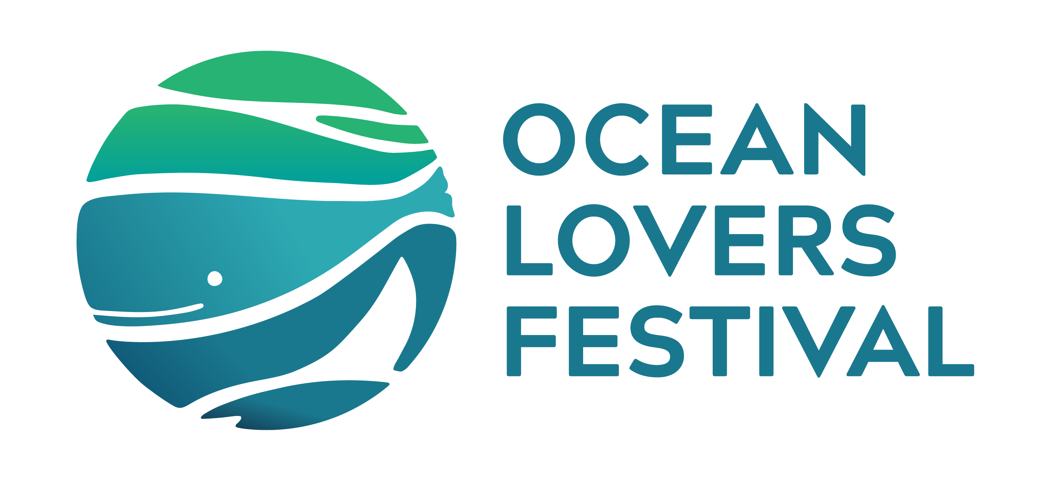

**Litterarty Lesson Plan Turning Trash into Treasure:**

**Art for Ocean Conservation**

**Year Group: Stage 2 and Stage 3 (Years 3–6)**

**Subject Areas: Visual Arts, Science and Technology, Geography, and STEM**

**Lesson Duration: 1 Hour**

**NSW Curriculum Links**

**Visual Arts (K–6)**

* **VAS2.1**: Represents the qualities of experiences and things that are interesting or beautiful through the arts.
* **VAS3.2**: Makes artworks for different audiences, reflecting experiences, ideas, and interests.

**Science and Technology (K–6)**

* **ST2-5LW-T**: Describes ways living things interact with each other and their environment.
* **ST3-5LW-T**: Explains sustainable practices that protect Earth’s resources and enhance environments.

**Geography (K–6)**

* **GE2-3**: Examines differing perspectives about the management of places and environments.
* **GE3-2**: Explains interactions and connections between people, places, and environments.

**Cross-Curriculum Priority**

* **Sustainability**: Develops knowledge, skills, and values to foster sustainable practices.

**Lesson Objectives**

By the end of the lesson, students will:

1. Explore the environmental impacts of waste on the ocean.
2. Understand the concept of reusing materials creatively to promote sustainability.
3. Design and begin creating an artwork using recycled materials that communicates an ocean conservation message.
4. Develop skills in collaboration, design thinking, and visual storytelling.

**Materials Needed**

* Collected recycled materials (e.g., plastic bottles, cardboard, old fabric, fishing nets)
* Scissors, glue, tape, and craft supplies
* Poster paper and markers
* Tablets or laptops for research (optional)
* Projector for videos or presentations
* Copies of the **Litterarty Competition** guidelines

**Lesson Structure**

**1. Introduction (10 minutes)**

* **Engage**: Ask the class, *"What happens to rubbish if it’s not properly disposed of? How might it affect the ocean?"*
* **Show**: Present a short video or images depicting the impact of waste on marine life.
* **Discuss**:
  + How does rubbish end up in the ocean?
  + What are some ways we can repurpose waste?
* **Introduce**: Explain the **Litterarty Competition** and how their artwork can be a powerful way to inspire others to protect the ocean.

**2. Brainstorming and Planning (15 minutes)**

* **Research and Inspiration**:
  + Share examples of artworks made from recycled materials (e.g., sculptures, collages).
  + Highlight the competition criteria: innovative use of materials, visual impact, and ocean message.
* **Group Discussion**: In small groups, brainstorm ideas for an artwork. Guide them with questions:
  + What message do you want your artwork to convey?
  + What materials could you use?
  + How will you combine materials to make your idea come to life?
* **Sketch Design**: Students create a rough sketch of their proposed artwork, labelling the materials they plan to use.

**3. Creative Workshop (30 minutes)**

* **Construct and Create**:
  + Students begin creating their artwork using recycled materials.
  + Encourage experimentation and collaboration within groups.
  + Support students in troubleshooting challenges (e.g., how to attach materials or make the artwork structurally sound).
* **Message for the Ocean**:
  + Each group writes a short poem, story, or statement to accompany their artwork, explaining its meaning and the importance of ocean conservation.

**4. Sharing and Reflection (5 minutes)**

* **Mini Gallery Walk**: Groups display their progress, and classmates provide positive feedback.
* **Reflect**: Ask students to share:
  + What they enjoyed most about creating with recycled materials.
  + How their artwork helps spread awareness about ocean conservation.

**Homework/Extension Activity**

* **Refine and Complete**: Students complete their artwork at home or in subsequent lessons, ensuring it meets the competition guidelines.
* **Visual Presentation**: Take photos or create a short video of the artwork, highlighting its features and the story behind it.

**Assessment Criteria**

* **Engagement**: Participation in discussions and creative activities.
* **Creativity**: Innovative use of recycled materials and original ideas.
* **Message**: Clarity and impact of the ocean conservation message.
* **Collaboration**: Teamwork and problem-solving during the activity.

**Adaptations for Stage 2 vs Stage 3**

* **Stage 2**: Provide structured templates for planning and simpler materials. Focus on basic techniques and concepts.
* **Stage 3**: Allow more freedom for independent design and encourage complex ideas or mixed-media approaches.

This lesson plan aligns with the NSW curriculum while supporting the Litterarty competition’s goals to foster environmental stewardship, creativity, and awareness among students.